Exp.No:36
36. Recognise watch from the given image by general Object recognition using OpenCV.

Aim:
To recognize a watch from a given image using OpenCV-based object recognition.
Procedure:
- Read the given watch image.
- Read the reference watch template.
- Convert both images to grayscale.
- Perform template matching.
- Find the best matching location.
- Draw a rectangle around the recognized watch.
- Display the result.
- Save the output.
Program:
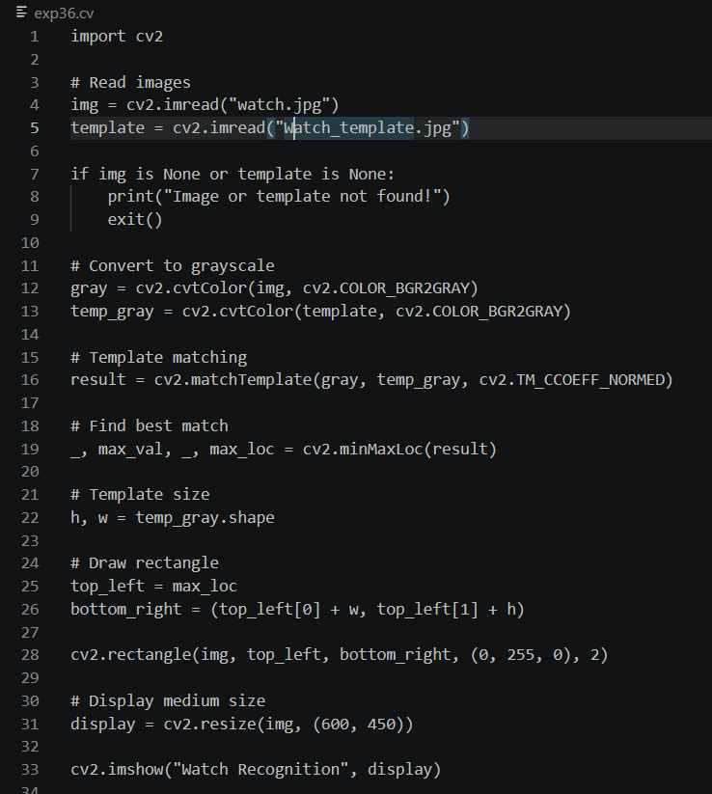

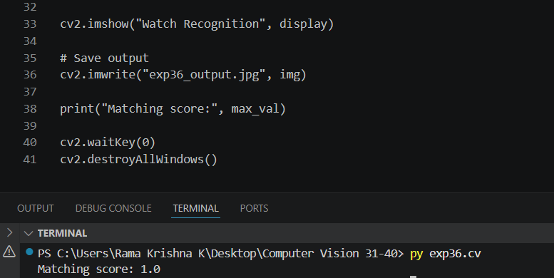

Input:
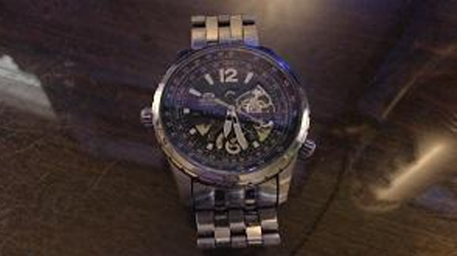

Output:
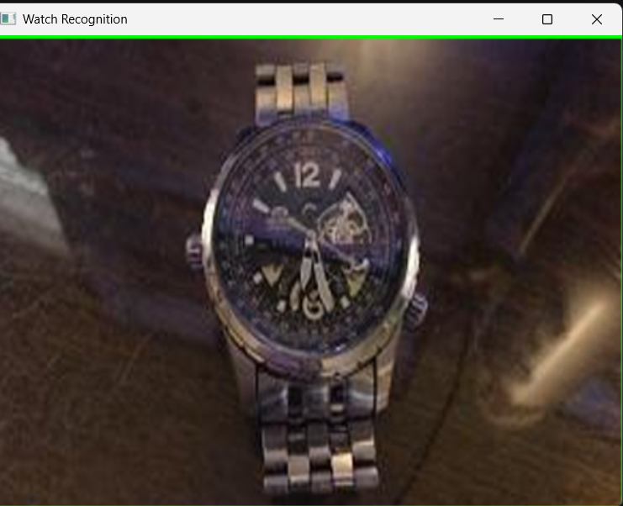

Result:
The watch was successfully recognized from the given image using OpenCV template matching.

